AI Glasses-Initial Frame#1
View | Satin Steel | White ABS
Isometric | 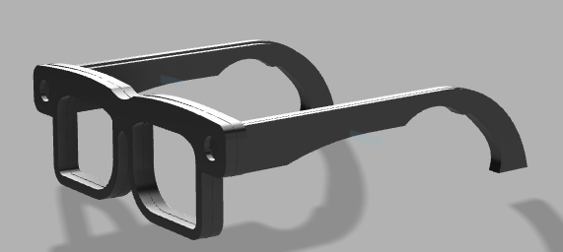 | 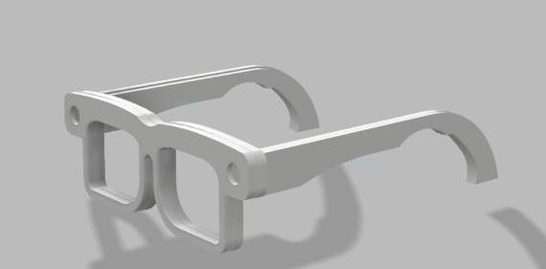
Front View | 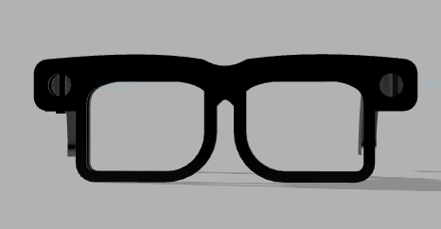 | 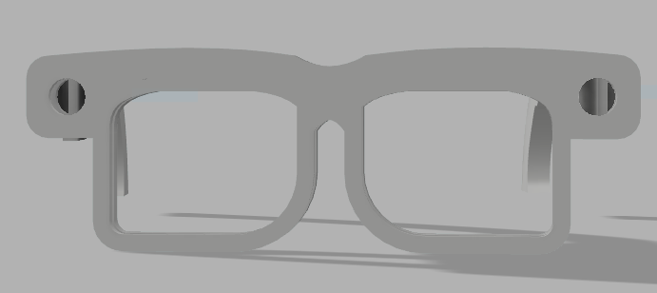
Side View | 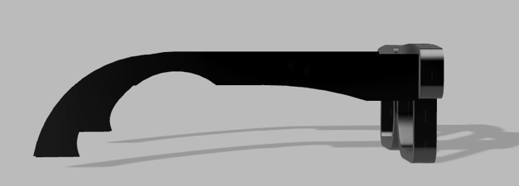 | 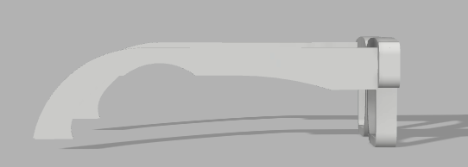

Design Overview:

Assembly:
Each Component of the glasses (Left Arm, Right Arm, and Front frame) Is made of two Bodies, The Outside Body (Figure 7) and a mirrored version of it to close it from the inside (Shown on figure 8)

Figure 7: Outside Bodies | Figure 8: Inside Bodies
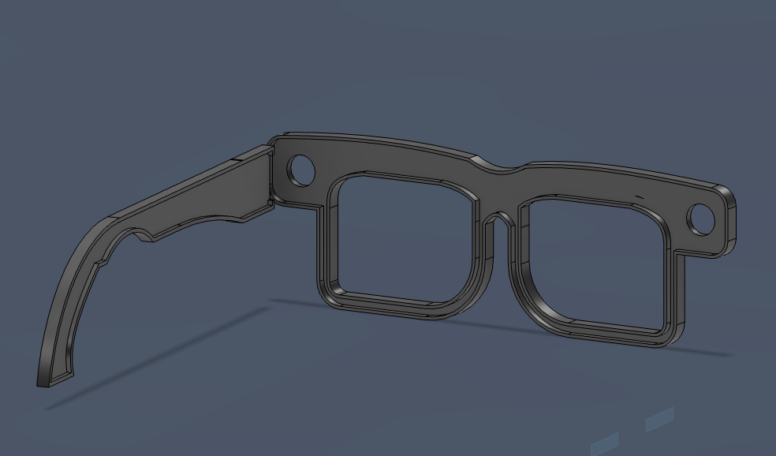 | 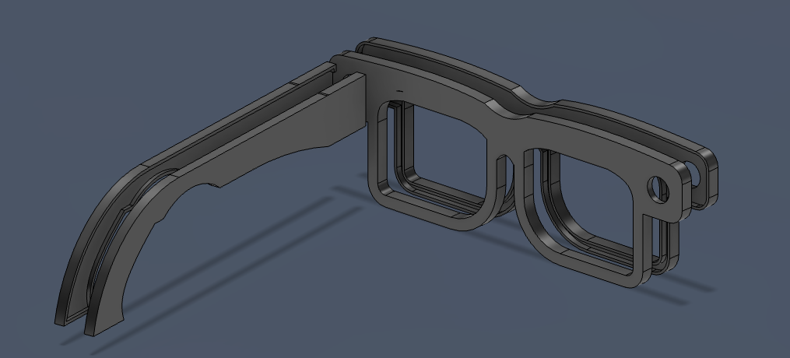

For initial Prototyping, the Two bodies will be Glued On to each other after the Hardware is placed inside the glasses, however this will Eventually Evolve into the two bodies being screwed on for a more secure fit.

Design Specifications:
Sidearm Piece
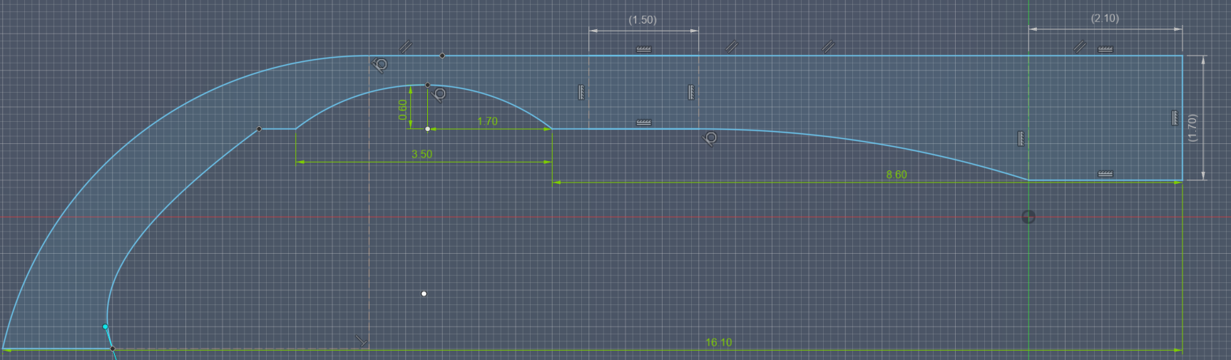
2.10x 1.70 cm Space allocated for ESP32C6
Space Allocated for batteries
1.50 x 1cm Space allocated for Speaker

Sidearm Notes:
- The curved Bend on the end of the piece may cause difficulties with the battery placement, will be reviewed after testing with the 4.5x1.5 cm 250mAh batteries

Front Frame:
10mm Diameter allocated for Ov2640 Camera
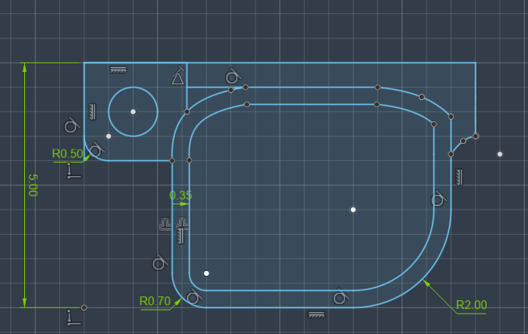

Front Frame Notes:
- Bezzel on top of frames is very thick, if found not necessary after testing, reduce its thickness
- Space For two Cameras for future Implementation (Can be removed now)

Other notes:
- Current Design Is a Rigid Body, The main improvement for next design is to implement a hinge that allows wires to be routed through them, such as:

- https://obe.de/media/pages/download/d05f66e3e4-1738594382/smartlink.pdf
- https://obe.de/en/news/scrivet-a-new-hinge-for-3d-printed-fra

